CS Hyde Company
1351 N. Milwaukee Ave., Lake Villa, IL 60046 Ph. 847-395-0325 Fax 847-395-0334 sales@cshyde.com
PRODUCT INFORMATION

19
-
__
F

Thick
UHMW Film

PRODUCT DESCRIPTION
UHMW is a super tough, abrasion resistant material. It has a high-slip/ non-stick surface similar to that of Teflon® but UHMW can take eight times the abrasion than that of Teflon® coated fiberglass and it is also very cost efficient. The UHMW film provides an excellent low friction, non-stick surface, in many ways similar to PTFE.

APPLICATION INFORMATION
The 19-F series is used primarily in mechanical applications such as chute liners, wear pads, and guide rails. It can also be used in such applications as a glide surface for computer mouse. With a temperature range up to 225ºF, Excellent UV, moisture and chemical resistance. Very versatile.

TECHNICAL DATA
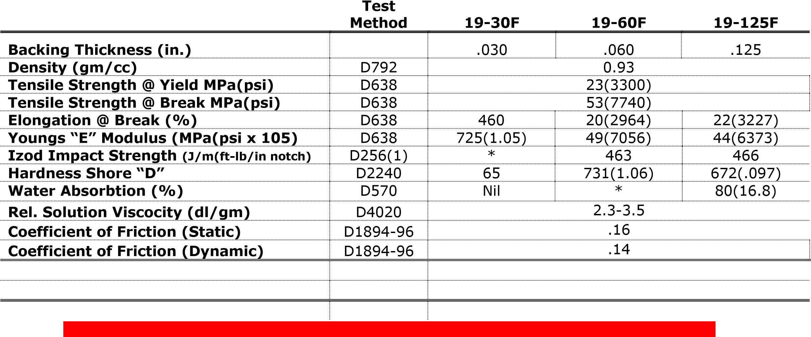
*The above values are "Typical Values" which have a nominal range about them and are not intended for specification purposes.

